**Tugas Praktikum OOP Modul 0**

**Nama : Ryan Muhammad Satria**

**NIM : 1202210047**

**Asprak : FATH**

**Link Repo :** <https://github.com/ryanmoehs/OOP-FATH-RYAN-1202210047>

1. Screenshot Hello World Java di VS Code

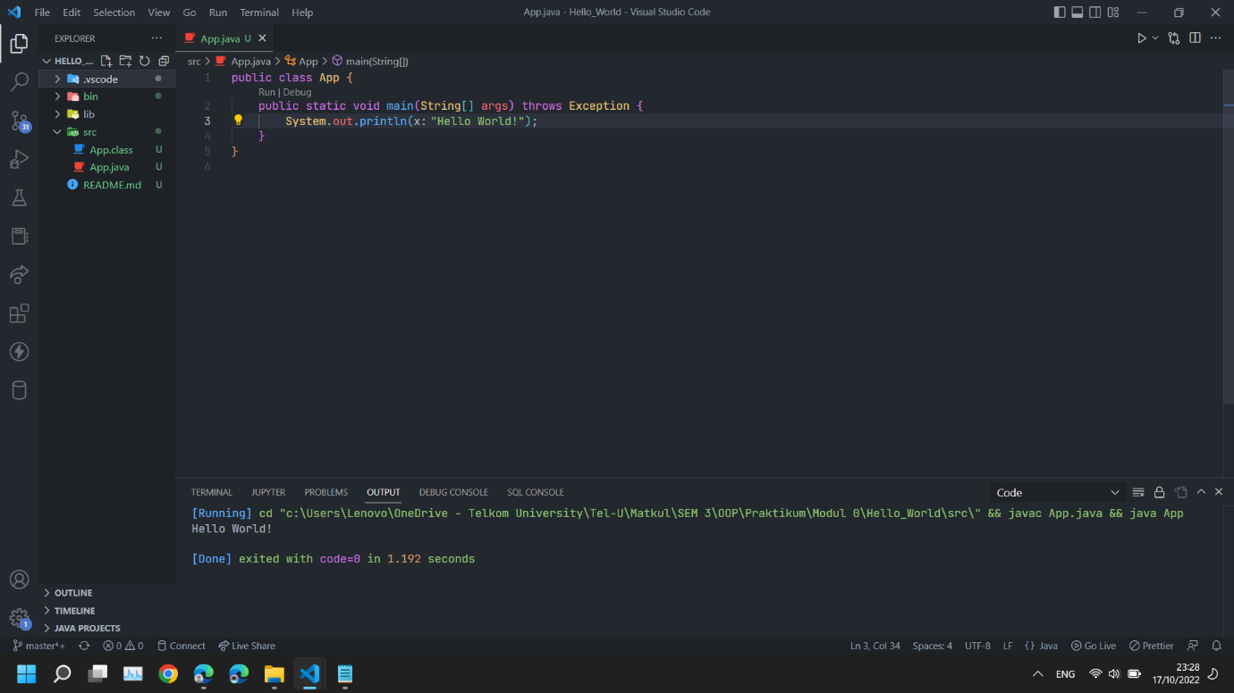

1. Bukti Push ke repository Github

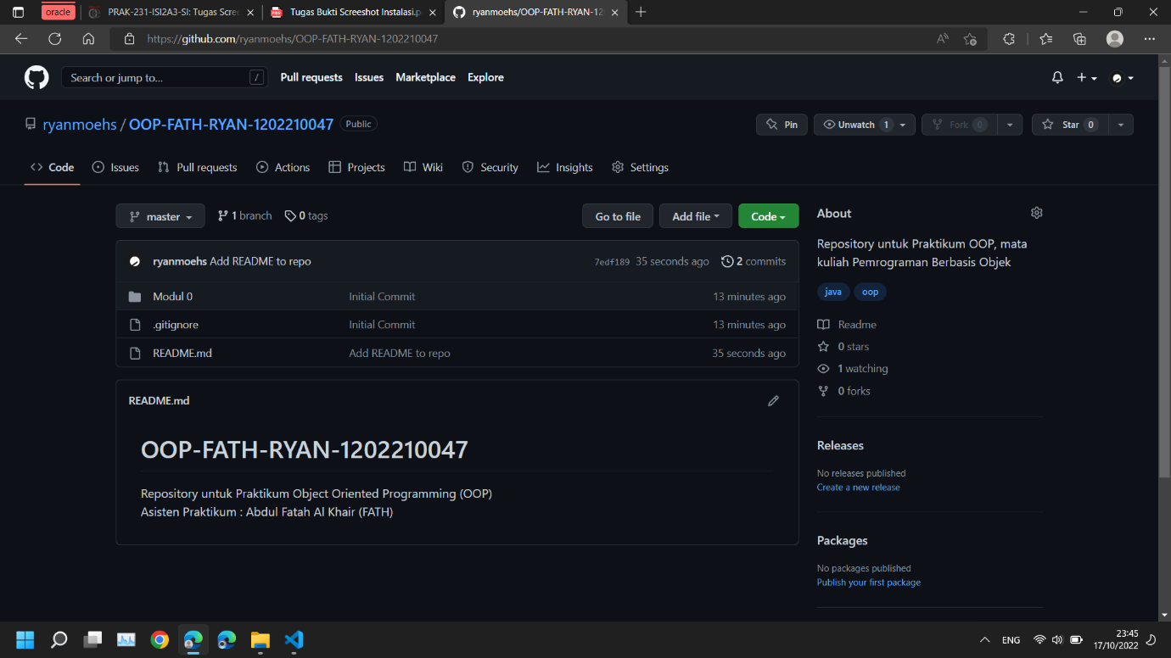

1. Bukti menambahkan asprak sebagai *Collaborator*

